**API DOCUMENTATION**

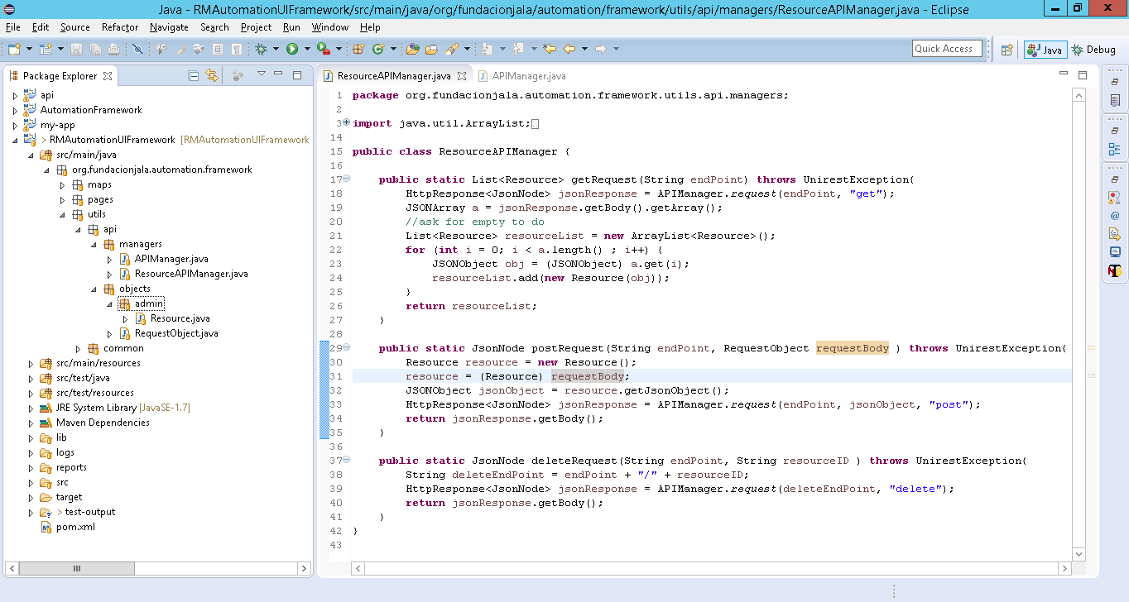

The generic class that has code for doing API Request is “APIManager”.

“ResourceAPIManager” is a specific class to convert the object to JSONObject for sending the correct parameters to “APIManager” for doing API request.

Resource is a class for creating an object it can be “Location, Settings, Resource, etc.” these classes contains attributes for each object.

This class also implements 2 constructors and 1 function.

1.- this constructor is for create the object this receives attributes.

2.- this constructor receives a JSONObject and create the object.

3.- this function is to return this object in JSONObject object type.

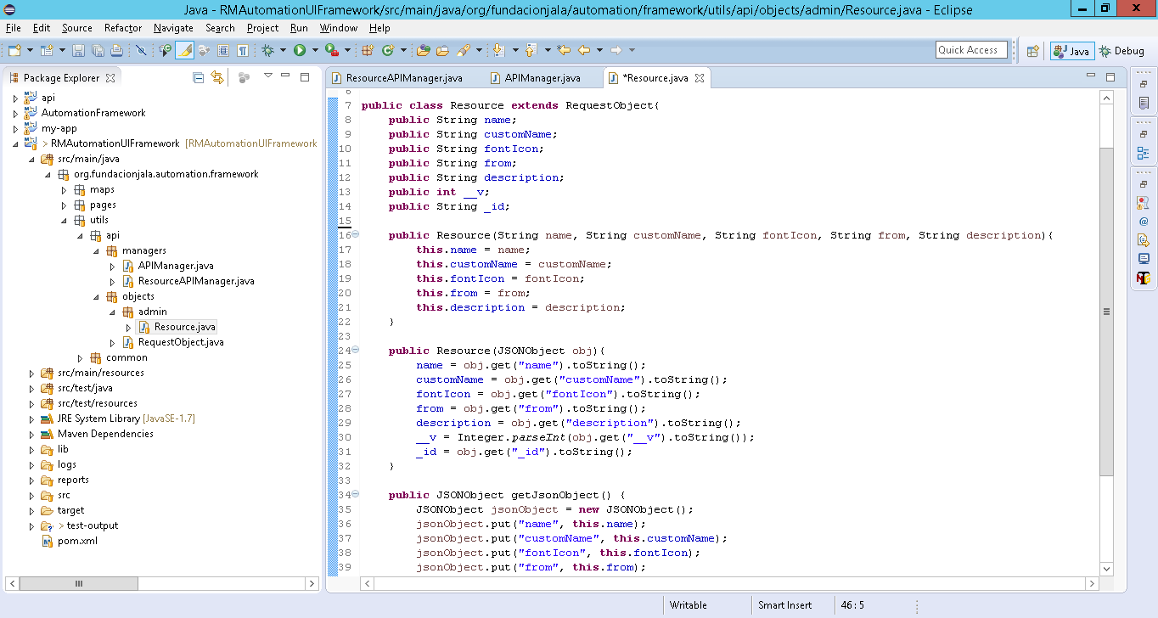

3

2

1

This class extends of RequestObject only for to be a generic class.

For creating other APIManager is necessary create a class with this constructors and method.

## How to create an “APIManager” it can be “LocationAPIManager, EmailServerAPIManager” or anything.

Creating the following functions with correspondent object, this class uses “request” function of “APIManager”.

The name of this class have to have “Object Name” + “APIManager”.

